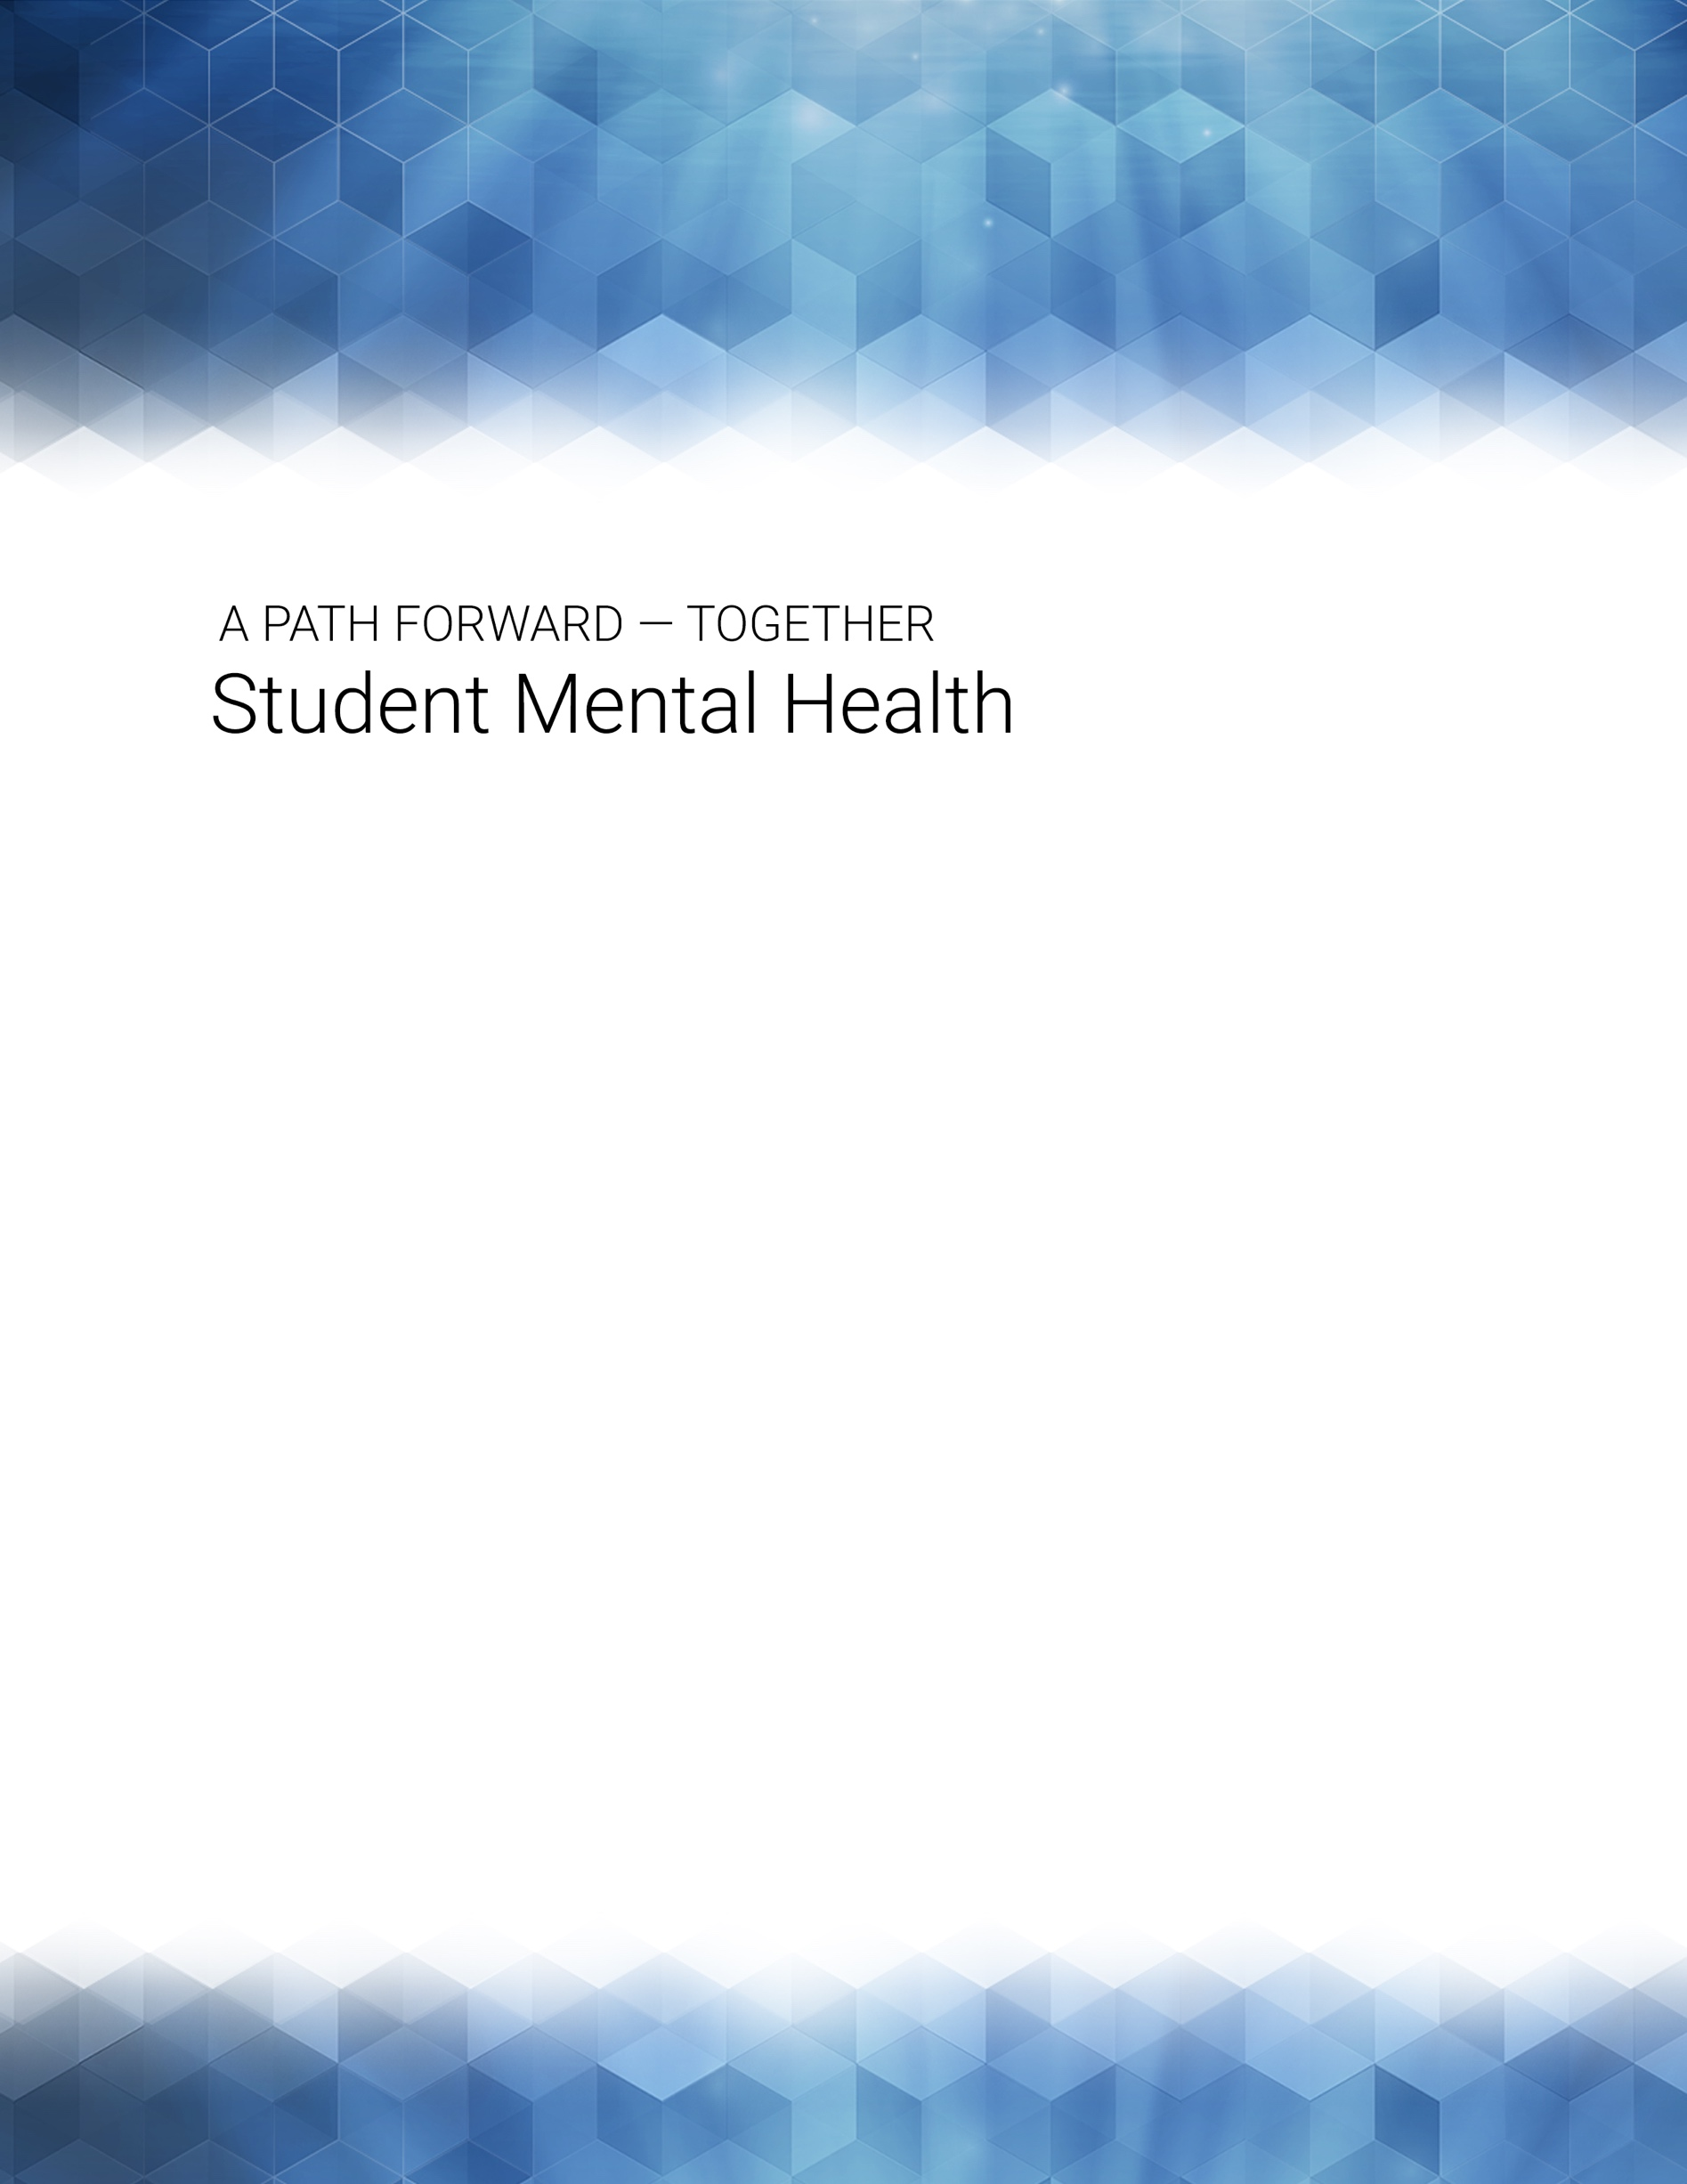

november 1, 2017

student mental health action team

Preliminary Report

STUDENT MENTAL HEALTH SUPPORT AT GEORGIA TECH

A Report Submitted to President G.P. “Bud” Peterson

from the Student Mental Health Action Team (Nov. 1, 2017)

Co-Chairs: Jenny Singleton and Emily Hale

Undergraduate Student Members: Alex Grady, Rachel Jinks, Andrew Perry, Rachael Price, Zoe Sieling

Graduate Student Members: Rachel Boyd, Vaisakh Haridas
Faculty Members: Gregory Abowd, Robert Butera, Pinar Keskinocak, Julia Kubanek
Staff Members: Drew Adelman, James Black, Mandy Garcia
Georgia Tech Liaisons: Dene Shehane, Lynn Durham

Mental health is defined as a state of well-being in which every individual realizes his or her own potential, can cope with the normal stresses of life, can work productively and fruitfully, and is able to make a contribution to her or his community. (World Health Organization, 2017)

- Introduction

According to the National Alliance on Mental Illness, one in five college-aged students faces a mental health condition (www.NAMI.org). With the rising numbers of college students experiencing stress, anxiety disorders, and depression, universities are finding themselves unprepared to meet their needs. We must attend to providing appropriate mental health support and suicide prevention to these young adults in our charge, yet some argue that a university's primary responsibility is educational, and they are not in the business of providing comprehensive and ongoing behavioral health. Families and students often believe that universities will provide both immediate and long-term mental health care, but most institutions are not equipped to do so. Further, institutions must be concerned about risk mitigation with respect to students who are experiencing serious and chronic mental health challenges, but some students feel campus leaders are too quick to push students who are in emotional distress into off-campus hospitals or treatment — not allowing them to return until they have proven that they have received care. This strong "anticipatory" response may have the unintended consequence of students underreporting suicidal thinking out of fear that they will be asked to leave campus.

While many colleges/universities have increased their student counseling center support staff to improve student-to-staff ratios, increased attention is also being paid to improving student mental health awareness, along the lines of required alcohol and substance abuse and sexual violence trainings, as part of suicide prevention and stress-resilience building. This is especially important because serious mental health issues tend to emerge in young adulthood, and bright young college students often find themselves anxious about asking for help, something they have not needed to do in most of their academic histories.

Some mental health advocates maintain that more can be done to change campus culture to one that is more supportive of students with mental health needs, including reducing stigma, competitiveness, and academic stress. But this can be difficult and slow to change. Universities are unlikely to lower their standards or rigor, but they can work to signal that asking for help is not a weakness and that "atypical pathways" may not be as uncommon as students perceive. Some institutions have launched programs or campaigns where academic role models show what it is like to recover from a failure experience, or convey that taking different (but still successful) academic pathways is okay, and showing students what the actual "typical" grade or course load is may help them adjust their perceptions of their relative performance.

University leaders often look to their peer institutions for trends and guidance, but they can also learn from basic scientific research in areas such as developmental neuropsychology; adolescent brain health; emotion regulation; risk factors and protective factors related to well-being and stress; and interventions that reduce mental health stigma, improve help-seeking behavior, and consider the mental health needs of underrepresented minority and non-traditional students.

Considering these national trends in student mental health, Georgia Tech has made some progress, but we can do more.

- Background

Georgia Tech’s strategy for supporting student mental health operates at the levels of individuals and the campus community, with outreach programs as well as preventive and treatment services for students. Georgia Tech offers a number of services that support student mental health and well-being. The key units are Georgia Tech Counseling Center (Dr. Mack Bowers, Interim Director), Stamps Psychiatry (Dr. Shannon Croft, Lead Psychiatrist), Health & Wellbeing (Suzy Harrington, Executive Director), and Office of Disability Services (Director-unfilled) for academic accommodations. There are many other programs, initiatives, and student organizations that also operate in this domain. (See Appendix A for a resource list.)

In 2013, President G.P. "Bud" Peterson formed a Mental Health Task Force, chaired by Lynn Durham, Office of the President, to evaluate mental health services and conduct a "broad review of campus units and their impact on mental health concerns raised by students." Their recommendations, along with a 2017 progress update, are attached in Appendix B. The most significant of the recommendations was to establish the Health & Wellbeing Initiative and hire its Executive Director, Suzy Harrington; and, to provide additional resources (to increase staff and space availability) for the Georgia Tech Counseling Center. However, a number of recommendations from the 2013 Task Force have not been implemented yet. In addition, Provost Bras charged a Task Force on the Learning Environment (2015), led by Dean Paul Goldbart and Chair of Mechanical Engineering Professor Bill Wepfer; this task force also had some recommendations for easing the stressors experienced by students in the classroom. Again, this task force's recommendations have not been fully implemented yet.

Several important Georgia Tech student surveys shed light on the student experience as it relates to stress and mental health, for example, Undergraduate Exit Surveys, Campus Climate Survey, Graduate Student Experience Survey, and the Black Student Experience Task Force Recommendations. These surveys, and the 2013 Mental Health Task Force report, point to common themes of overwhelming academic pressure, competitiveness, and isolation/lack of belongingness that can result in elevating student stress, perhaps to an undesirably high level, negatively impacting student productivity and learning, and causing emotional distress. Data from the 2011 National College Health Assessment (NCHA) revealed that 89.9% of Georgia Tech students reported they were "very stressed" while the national rate was 52.9%. We recognize that Georgia Tech is a highly ranked, elite academic institution, with ever-increasing admissions standards and a demanding curriculum. Add to that, the financial advantage of (but the pressure to keep) the Hope/Zell Miller Scholarships, carried by so many of our students. Georgia Tech Alumni perpetuate the lore of "getting out," "drownproofing," and "look to the left, look to the right," highlighting the rigor and competitiveness of the environment at Georgia Tech. Georgia Tech has an increasingly more diverse student body, with international and out-of-state students, a broad curriculum, and, as is true nationally, a higher rate of mental health concerns. While we have much to celebrate about the excellence and success of Georgia Tech, we need to pay closer attention to the impact of our students' mental health and long-term well-being and success.

Following the death of Georgia Tech undergraduate student Scout Schultz in September 2017, President G.P. "Bud" Peterson established four Action Teams to make recommendations on "A Pathway Forward," including this Student Mental Health Action Team. We met over a period of 4 weeks, collected information from stakeholders, service providers, faculty, staff, and students, benchmarked local and peer institutions, and explored recent research findings on collegiate mental health. Our final report begins by offering some data on mental health services at Georgia Tech, providing data and practices from other institutions regarding student mental health in higher education.

- Benchmarking of Georgia Tech programs with other institutions

In our benchmarking efforts, we focused on peer institutions with similar sizes and/or populations of students including: Carnegie Mellon University; MIT; Purdue; Stanford; University of California – Berkeley; University of Illinois at Urbana-Champaign; University of Michigan; University of Texas at Austin. We added Emory University due to its proximity and similar urban environment to Georgia Tech, and Cornell University and University of Pennsylvania because of recent public attention to student mental health at these institutions.
Georgia Tech has a similar range of programs and services to these peer and near-peer institutions. All of these universities (and many others across the nation) have reported increasing need for and use of student mental health services. Representatives from some of these institutions expressed deep concern for unmet student need and fear that their resources will be inadequate to meet needs within the near future. Georgia Tech asks students seeking help at our Counseling Center whether they have ever attempted suicide; the rate of a “yes” response has steadily increased from 5.9% (2014) to 7.1% (2015) to 8.5% (2016) to 9.5% (2017). No other institution that we surveyed collects exactly this kind of data, but all expressed alarm to hear of Georgia Tech’s increase and surmised that the rate of distress among their students is similarly rising.
Appendix C compares student mental health experience, counseling and psychiatric services, and clinical staffing for Georgia Tech and the institutions named above. Data were not available for all categories from all institutions. However, the following innovative programs at these institutions are worth noting in more detail:
  - iCARE Gatekeeper training and Wellness Partners and Wellness Ambassadors at University of Pennsylvania: With iCARE, faculty, staff, and students undergo a full day of training to recognize student distress and refer them for help. To date, 2000+ personnel have been trained including almost all student leaders. It is not mandatory for faculty. Several hundred faculty and staff who have been trained by iCARE have then elevated their training to become “Penn Wellness Partners,” who serve as a point of contact for students to talk about concerns and get referrals. Penn Wellness Partners also look out for students in need and have stickers on doors and briefcases advertising their role. Other iCARE-trained faculty serve as “Penn Wellness Ambassadors” who act as a resource to fellow faculty members.
  - Cornell Air Force model: In partnership with the Jed Foundation, Cornell adopted a strategy published by Kerry Knox at the University of Rochester, modeled on a successful Air Force program to reduce suicide rates. Cornell’s program involves specific activities associated with seven components: 1) foster a healthy learning environment; 2) foster social connectedness and resilience; 3) increase help-seeking behavior; 4) identify students in need of care; 5) integrate medical and mental health services; 6) deliver coordinated crisis management; 7) restrict access to suicide.
  - Purdue’s police crisis intervention team: Purdue’s police force includes several officers specially trained in student mental health, forming a crisis intervention team (CIT) when partnered with regularly trained police. These teams support resident life teams after-hours and are also available during daytime hours. They can help make quick assessments and direct help appropriately. Other communities (e.g., City of Toronto) have CITs that consist of police partnered with a professional counselor expert in mental illness, who go out on calls together.
  - UT-Austin’s embedded counseling model: UT’s Counselors in Academic Residence (CARE) program uses an embedded counseling model to reach students who might otherwise not visit their counseling center. The CARE counselors are embedded in colleges and academic programs where they learn about the concerns of students in specific academic disciplines. They use this learning to design and implement tailored therapy groups. The CARE counselors are members of the colleges and integrated into staffing; they also help faculty understand pressure points for students.
  - Cornell’s counseling center triage system: The triage system is designed to lower barriers to access to help. Students seeking help complete an online form (from wherever they are) to request services, and therapists respond with a scheduled 20-minute phone conversation within 24 hours. If the therapist deems the need urgent, the students gets an in-person appointment with counseling staff within 72 hours; if not as urgent, then students might wait up to three weeks for a counseling appointment.
  - MIT’s Mind-Hand-Heart Initiative and CARE Teams: http://mindhandheart.mit.edu/ The MindHandHeart initiative is working at the intersection of wellness, mental health, and community at MIT, to launch new efforts that coordinate and improve support services and enhance overall well-being. The CARE Team (Coordination, Assistance, Response, and Education, http://studentlife.mit.edu/careteam) is a team of staff who support all students through challenges they may experience during their time at MIT. While MIT has many resources to support students, the CARE Team recognizes it can often be overwhelming for students to navigate all of the support available to them.

Usage of Georgia Tech Counseling Center and Psychiatric Services compared with peers
Georgia Tech’s varied mental health programs overlap with some peers, whereas others have initiated more original solutions to serving student mental health and building a supportive campus community. (See Appendix C and above.) Georgia Tech provides a variety of therapy sessions and clinical services, both for individuals and groups, consistent with those offered at peer institutions (Appendix C) and other U.S. universities (Table 1 below).
Table 1: Services provided at on-campus counseling centers across the U.S., reported via AUCCCD. Count indicates the number of institutions providing the stated service; percent indicates the proportion of reporting institutions that offer this service.
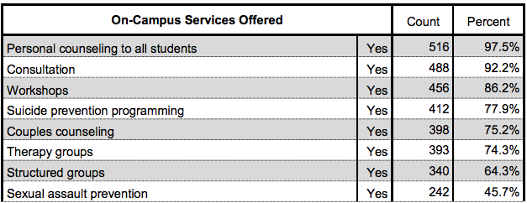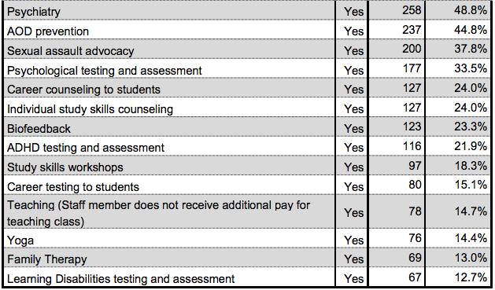

At Georgia Tech’s Counseling Center, the ratio of full-time students to full-time, certified counseling staff is currently 1578:1, higher than many peers and near-peers whose ratios range from 730:1 to 1732:1, averaging 1100:1. (These numbers are not intended to include psychiatric staff or uncertified counseling staff, but in some cases, those staff may have been included in peer institution data.) The nationally recommended ratio is 1000:1 to 1500:1 for a university of our size; UCCCD reports in its 2016 survey of universities that universities with 25,000-30,000 students have a mean ratio of 2567:1. There has been a steady increase in the number of new student clients at Georgia Tech’s Counseling Center since at least 2005; students visiting Stamps Health Center to access psychiatric services have also dramatically increased in recent years (Figure 1). Although the number of enrolled students has also increased during this time, increased enrollment does not fully account for the 50% increase in counseling center utilization since 2009 nor the 71% increase in visits to a psychiatrist since 2013.

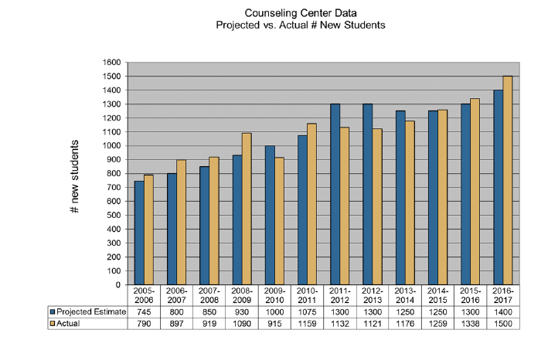

Figure 1: Student utilization of Georgia Tech Counseling Center (left) and Psychiatry (right) in recent years.

An open question is whether current averages and recommendations from professional societies sufficiently address existing need among current students. Students visiting Georgia Tech’s Counseling Center report concerns consistent with national patterns (Figure 2). While Georgia Tech’s student-to-counselor ratio may be high relative to peers, the limit on the number of counseling sessions is fairly liberal, at 16 (with the limit currently suspended, as of October 2017). Those peers and near-peers with limits are all set much lower, and institutions sampled that do not set limits on numbers of sessions typically work with students to move them to other resources within a smaller number of sessions. (See Appendix C.) Several representatives of peer institutions noted that they are in the process of adding counseling staff to reduce their student-to-counselor ratio.

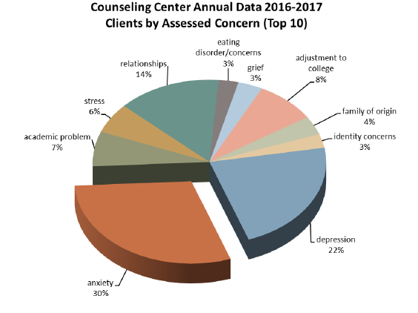
Figure 2: Top concerns of students visiting Georgia Tech Counseling Center. These are in line with national data trends from the AUCCCD and with national data from the Counseling Center Assessment of Psychological Symptoms (CCAPS), a multidimensional assessment and outcome measuring instrument utilized by the Georgia Tech Counseling Center.

- A Path Forward: Short-Term and Long-Term Recommendations from the Mental Health Action Team

The Student Mental Health Action Team (MHAT), made up of faculty, staff, and students, worked diligently and collaboratively to seek input from many stakeholders and individual members of the campus community. Our goal was to identify a pathway forward that ensures positive mental health for students at Georgia Tech. We share a commitment to effectively and appropriately support students who are experiencing emotional distress, identify and support those who may be at a higher risk for distress, and improve prevention efforts aimed to reduce stress and build stress resilience and coping strategies. We acknowledge the important contributions of previous Institute task forces that relate to these issues (Mental Health Task Force of 2013, and Task Force on the Learning Environment of 2015) and hope that the pathway forward revisits and implements their recommendations.
We felt there was open, honest dialogue and a collaborative mindset within our team and with those that we interviewed. Our team reached consensus on the following recommendations that address the mental health services available to students and the campus efforts toward reducing stress and building stress resilience. We propose an increased institute commitment to leadership, open dialogue, oversight, budget allocation, and student involvement toward student mental health support and prevention efforts. We recognize that there may be overlapping recommendations with the other Action Teams (LGBTQIA, Campus Culture, and future-Campus Safety), and at the end we point out some specific, but not exhaustive, “intersecting” recommendations that may also be considered by those teams.

Recommendations [S] = Short-Term

Leadership and Coordination of Education and Support for Mental Health Services and Prevention Efforts

1. Establish resources for centralized campus leadership and coordination of mental health support on campus with the goal of monitoring trends, improving mental health service provision, and reducing what appears to be higher-than-peer-average rates of stress, anxiety, and suicidal thinking. The Action Team expressed concern over lack of complete follow through with prior recommendations of the Mental Health Task Force (2013) and the Task Force on the Learning Environment (2015), thus we see a strong need for improved oversight as we move forward. Toward this goal, we recommend that President Peterson:
- Designate an administrative leader who will head a Mental Health Advisory Council (with students involved), serve as a bridge between auxiliary units supporting mental health and academic units, and oversee short-term and long-term implementation of MHAT and previous task force recommendations. This leader will be instrumental in organizing faculty and academic advisor training and development, reviewing academic structural barriers, and shifting academic culture while preserving academic rigor, all while balancing institutional/legal constraints and risk management.
- Establish a budget and develop a strategic plan to coordinate campus efforts to support student mental health needs.
- Establish a campuswide Student Mental Health Advisory Council (or other "standing committee") made up of key stakeholders and undergraduate/graduate students.
- Implement continuing periodic student surveys on mental health (last time was 2011). This would involve collaboration with the new Assoc. Provost for Academic Effectiveness (Loraine Philips), and possibly embedding sections on mental health in other regular student surveys.
- Widen the accessibility of de-identified survey results to campus constituents.
- Provide resources/support for implementation following surveys (e.g., Grad Student Experience Survey has some key recommendations, but no clear resources for implementation).

Recommended Actions to Improve Student Mental Health at Georgia Tech

2. Improve how students gain access to information about mental health resources and seek help in a mental health crisis.

- [S] Explore new technologies, tele-health, one-touch apps, centralized e-portal for information access (e.g., easy link to get guidance and resource numbers on their mobile devices).
- [S] Lower the help-seeking barriers. Go to where the students are (don’t wait for them to come to Georgia Tech Counseling Center); expand reach to students who may be at greater risk for mental health concerns.
- Satellite counseling centers or drop-in hours.
- Expand outreach abilities of the counseling center (e.g., more frequent depression screenings across campus, "Let's Talk" programming).
- Expand mental health information in FASET and GT1000; implement similar learning opportunities for sophomores/juniors/seniors. Current information is insufficient, not standardized. Ensure that PLs/RAs are adequately trained and have all the information they need. Get information to parents.
- Expand mental health information to graduate students: Increase unit encouragement for attendance to Institute Grad Orientation; promote onboarding grad students programs such as "Grad Groups."
- Look to other institutions for model programs/approaches. Some compelling models our Action Team discovered (see Benchmarking section) include:
  - Cornell University’s version of the Air Force Model, which involves specific activities associated with a 7-component “wheel” as a framework: 1) foster healthy learning environment; 2) foster social connectedness and resilience; 3) increase help-seeking behavior; 4) identify students in need of care; 5) integrate medical and mental health services; 6) deliver coordinated crisis management; 7) restrict access to suicide.
  - University of Pennsylvania’s iCare, Gatekeeper training, and Wellness Partners & Ambassadors, which train a subset of the faculty to act as portals for referral and information to students and to other faculty.
  - Purdue University’s police crisis intervention team.
  - University of Texas at Austin’s embedded counseling team.

3. Initiate programming, events, education, and physical spaces that build student's stress resilience, sense of belonging, and reduces mental health stigma.

- Give additional consideration to those students from groups that may be especially at-risk for emotional distress, stress, and isolation (e.g., URM-in context students, international students, "re-entry" students following academic dismissal/warning/probation; survivors of sexual assault and interpersonal violence).
- Understand that graduate student needs (and the mental health stressors) are different than undergraduates in that they fall more onto advisor relationships, lab dynamics, work-life balance, financial stress); re-publicize information on campus resources for graduate students to seek help (e.g., consider adding this information to the Mutual Expectations for Research Advisors/Advisees document); improve dialogue between academic units’ graduate student councils and their unit administration.
- Increase involvement of campus entities that are not traditionally thought of by students as “mental health”: Georgia Tech Arts; Health & Well-Being, Campus Recreation Center, Academic Advisors, and other entities from whom students seek support (e.g., campus chaplain community).
- Promote programming that is meaningful to underrepresented minorities on campus (e.g., LGBTQIA, OMED, Women’s Resource Center, Office of Disabilities).

4. Improve Mental Health Services at Georgia Tech.

The MHAT recognizes that there exist different models of mental health service provision to students within a university environment, ranging from crisis-only, to short-term care, to comprehensive and/or long-term care. We recommend a more detailed evaluation of usage patterns, access-time, and diversity statistics of the primary mental health providers at Georgia Tech: Georgia Tech Counseling Center, Stamps Psychiatry, and Health & Well-Being.

Based on our review of the current state of operations, we recommend that Georgia Tech work toward a ratio of 1000:1 of full-time students to full-time, certified counseling center staff. (AUCCCD recommends a ratio between 1000:1 and 1500:1 for our size institution.) Specifically, we recommend that Georgia Tech:

- [S] Increase the number of full-time counseling staff at GTCC, with attention to diversity, and re-evaluate salary levels to ensure Georgia Tech is competitive in recruitment and retention of GTCC staff.
- [S] Add an additional full-time psychiatrist to Stamps Psychiatry Clinic to meet increasing demand for services.
- [S] Increase “case manager” staff at GTCC to follow up on student-clients to ensure they are receiving the support they need, continuing verification of referral network.
- [S] Evaluate quality of care offered by external providers and address transportation (and other concerns) to off-campus clinicians.
- [S] Provide funds to expand number and type of clinicians available to help students. For example, we could include more licensed master’s-level clinical staff, postdocs, interns (compared to licensed psychologists).
- [S] Ensure that “interim” status of GTCC director is resolved soon.
- [S] Address space constraints in GTCC in order to accommodate the greater needs, increased staff, and recommendations for additional programs/services.
- Evaluate roles, scope, and coordination of GTCC, Stamps Psychiatry, Health & Well-Being (e.g., What treatment should they offer? How might they more efficiently coordinate and share records so as to reduce student frustration with repeating forms?)
- Evaluate intake process, time to first appointment (evaluation) and second appointment, how to get into support groups, process of referrals, and usage of other services.
- Currently, Georgia Tech Counseling Center is a short-term clinic. Given our preliminary review of usage statistics, we do not see a need to enforce a fixed session limit; rather, we see the need for better Student:Staff ratio (Recommend: 1000:1), improving education to students about the scope of GTCC services, and improving the referral and “hand off” process so that students can get appropriate and adequate long-term care if they need.
- Explore the option to expand Georgia Tech Counseling Center to offer longer term counseling where appropriate to students on a fee-for-service basis or develop standing relationships with local off-campus clinics to reduce the evident gaps in Atlanta-area referral network.
- Address structural challenges and legal barriers to providing mental health support to Georgia Tech students who are not physically on campus (e.g., Georgia Licensure prevents GTCC staff from providing tele-health support to study abroad students or out-of-state co-op or internship students) or temporarily not registered (e.g., in summer term); possible “cobra” extensions of Student Blue Health Insurance during leaves of absence.

5. Broaden the “community of care” to build stress resilience and address student mental health concerns before they intensify.
- [S] Increase training and use of academic advisors and faculty directors to support students.
- [S] Enhance faculty understanding of student mental health issues and increase empathy through required (short and periodic) training, e.g., new faculty orientation and online modules.
- [S] Enhance TA training related to mental health support resources, procedures, identifying students in distress, and increasing empathy.
- Promote and support C2D2’s holistic view of career development, recognizing the pressures that the job search or graduate program application process adds.
- Increase and enhance peer education strategies (e.g., QPR, “Let’s Talk”) and programs focusing on how to help a peer in distress.
- Expand peer coaching (including “Grad Fellows"), wellness activators, and “buddy escorts to GTCC” for broader mental health support.
- Publicize and expand Health & Well-Being scope: helping students with multiple strategies to build stress resilience and emotional regulation; offering more de-stress activities, exercise, strength finders, and coping strategies to the students at CRC and in other spaces that may be more inviting (e.g., in their dorm, at Clough Commons, etc.)

6. Revisit structure and content of APPH 1040/1050 health courses.

How can we leverage this USG requirement to improve mental health education? Current dominant focus and instructor expertise place mental health in a physical health context, which nevertheless results in many students coming forward to seek mental health referrals.

- [S] Recommend revising curriculum and adding instructor(s) with formal training in mental health to create co-teaching teams that more fully integrate mental and physical health, while reducing student-to-faculty ratio enabling additional small group discussions and exercises.
- Challenge: This course is not always taken in first year and does not include graduate students.
- Challenge: Adding another required course for all students would likely get pushback from majors that are already at maximum credit hours for graduation.

7. Modify “academic infrastructure” that may be unintentionally increasing the psychological stress experienced by students.

- Consider adding additional "forgiveness" grade replacement beyond freshman year; explore increasing number of pass/fail options permitted. (Interestingly, MIT has first semester all Pass/Fail.)
- Address the often unclear/inconsistent/ever-changing grading policies in Georgia Tech courses (e.g., students report that a professor who grades on a curve creates a learning context where students never know where they stand, and this may increase competition between students).
- Improve coordination of exams throughout the semester. For example, there are many more exams assigned the week before Progress Reports are due.
- Improve faculty communication about due dates for homework assignments and quizzes — assigning them at least one week in advance, and with definite due dates (preferably already clearly scheduled at the beginning of the semester so that students can better plan).
- Better enforcement of compliance to syllabus requirements and other policies related to classes. Require statement within all course syllabi that points students toward campus resources for mental health and academic success (similar to academic integrity and disability statements).

8. Identify financial pressures contributing to student stress and provide clear communication about financial and insurance consequences (and options) if a student needs to withdraw from a class, take an incomplete grade, modify graduate assistantship duties, or take a leave of absence related to mental health issues.

- [S] Provide students with clear information regarding financial consequences of falling below GPA or progress requirements of their academic program (e.g. Hope/Zell minimums, research milestones in graduate programs), what their financial options are, and how to access emergency loans.
- [S] Provide more financial education workshops for students to reduce stress associated with not knowing how to plan or find support (e.g., follow through with recent successful pilot program on Financial Advising).
- [S] Enforce policy that requires academic units to conduct annual review of graduate stipend levels.
- [S] Encourage deans of Colleges to conduct comparative reviews of graduate stipends within their Colleges.
- [S] Provide clear financial information regarding stipend, fees, costs to prospective and incoming graduate students to enable them to better plan for their financial needs.
- Investigate how Georgia Tech might be able to reduce student fees for graduate students outside of the tuition waiver.
- Review inconsistent policies across units regulating graduate students’ workload, e.g., some units forbid students working beyond 20 hours/week, taking part-time work off campus.
- Reduce stigma of taking a one-semester leave of absence to work/replenish funds for education.

9. Improve our ability to identify students in distress earlier.

- [S] Make it easier for peers to report their concern for a fellow student in distress (e.g., current online form with Dean of Students requires input of the distressed student's GTID number, which may not be easy for a peer to obtain).
- Explore the use of existing databases and predictive tools to identify students who may be at greater risk.
- Better coordinate existing databases of shared notes/actions from different units pertaining to students needing support; this will reduce student frustration with repeating forms.

10. Improve disability services for students with mental health accommodations (and all students with disabilities).

- [S] Inadequate staffing of Office of Disability Services needs immediate attention. This includes increasing the staff (including testing center staff) and filling the open leadership position now. Fall 2017 was wrought with many challenges for this office, resulting in greatly increased stress placed on students requiring accommodation.
- [S] Evaluate effectiveness of the new "Accommodate" program for management of accommodation requests, test scheduling, notetaking. The system was implemented in Fall 2017 with no instructions to faculty.
- [S] Find space for a testing center that appropriately accommodates student testing needs (inadequate space for low distractibility testers).
- Evaluate multi-use testing center (revenue generating for LSAT, GRE, etc.) as part of Library or other building projects.
- Better training for faculty around the importance of accommodations and legal ramifications of not providing accommodations.

The Mental Health Action Team acknowledges some of the intersectional themes with other Action Teams:

CAMPUS CULTURE: Through our information gathering, we see the recurring themes that can be attributed to our campus culture, which likely have some impact on student mental health, e.g., heightened competitiveness, marginalization, “united in suffering,” “getting out,” and the emphasis on “numbers/rankings” as part of student identity. A culture shift will need to happen with buy-in from faculty, staff, students, and alumni to make headway focusing more on the people who are part of a community of care, the positives to “being here” rather than “getting out,” a sense of belonging, and mastery mindsets over competitiveness.

LGBTQIA: Our Action Team recognizes the importance of increased awareness of campus administrators/faculty/staff/advisors of the higher risk for mental health concerns among this group of students. (See national trends.) We ask whether the proposed recommendations will adequately meet LGBTQIA student needs, beyond the simple solution of increasing diversity among GTCC staff. It will be important to increase awareness amongst the campus community of the available support for LGBTQIA students. We seek to dispel the myth that GTCC referring to an off-campus clinician will potentially "out" a student to their parent(s). We ask for clearer communication of how Student Blue Health insurance protects privacy and "safety" of our students in the LGBTQIA community.

CAMPUS SAFETY: We recognize that the Campus Safety Action Team has not yet formed, but we want to document our recommendations that are relevant to that Team’s work.
- [S] Evaluate GTPD's training and procedures related to student mental health.
- [S] Address student fears and perceptions of "calling police" for mental health concerns; how does this reporting interface with Dean of Students "concern reports"?
- [S] Evaluate content and timeliness of campuswide crisis communications (including GTENS) to avoid conveying confusing, or distress-inducing messages; to avoid the perception of lack of empathy (legal, robotic language).
- [S] Evaluate protocols regarding suicide risk-increasing settings (e.g., roof access).
- Explore whether embedding non-police personnel (e.g., crisis intervention specialist) within GTPD would build trust and care for students who are in mental health crisis.

Student Mental Health Action Team Report (Nov. 1, 2017)

Appendices

Appendix A: Mental health resources currently available to Georgia Tech students
Appendix B: 2013 Georgia Tech Mental Health Task Force recommendations
Appendix C: Benchmarking data from Georgia Tech, peer institutions, and national organizations based on publicly available websites, reports, and telephone interviews with administrators conducted in October 2017.

The three appendices are contained in separate documents.

